You can choose any methods to setup your task.

Options you have to enter value when use getsmscode phone service before run:
1, UserNameTable.
2, UseSMSPVA: Enter 1 or 0. 1 means use smspva/getsmscode phone number to register. 0 means use your email address to register.
3, SMSUserName: the username of your getsmscode account you registered.
4, SMSToken: the token of your getsmscode account.
5, VerifyPhone: enter 1 or 0. 1 means you must verify the phone number. 0 means do not have to.
6, PhoneService: enter 1 or 0 to choose which phone number service you will use. Please enter 0. 1 means use smspva phone number service. 0 means use getsmscode phone number service.
7, RegisterWay: enter 1 or 0. 1 means use phone number to register. 0 means use Email address to register.
8, EmailTable: enter your email to register. You can search your email server settings in your browser. Eg: sunnyyong43@outlook.com i can find its server settings here: https://www.outlook-apps.com/outlook-com-pop-settings/
Email: sunnyyong43@outlook.com
Protocol: POP3
Server: pop3.live.com
Port: 995
SSL: YES
Verify: 0
9, TableProfile: enter your photo path in “ProfilePhoto” option. Enter your bio in “Bio” option.
10, PhoneCountry: choose use which country phone number to register.
- Chinese 1-Cambodia 2-Malaysia.....

Options you have to enter value when use smspva phone service before run:
1, UserNameTable.
2, UseSMSPVA. Enter 1 or 0. 1 means use smspva/getsmscode phone number to register. 0 means use your email address to register.
3, VerifyPhone: enter 1 or 0. 1 means must verify the phone number. 0 means do not have to.
4, PhoneService: enter 1 or 0 to choose which phone number service you will use. Please enter 1. 1 means use smspva phone number service. 0 means use getsmscode phone number service.
5, smspvaApiKey: enter the apikey of your smspva account.
6, RegisterWay: enter 1 or 0. 1 means use yourself phone number to register. 0 means use Email address to register.
7, EmailTable: enter your email to register. You can search your email server settings in your browser. Eg: sunnyyong43@outlook.com i can find its server settings here: https://www.outlook-apps.com/outlook-com-pop-settings/
Email: sunnyyong43@outlook.com
Protocol: POP3
Server: pop3.live.com
Port: 995
SSL: YES
Verify: 0
8, TableProfile: enter your photo path in “ProfilePhoto” option. Enter your bio in “Bio” option.
9, PhoneCountry: choose use which country phone number to register.
0-Russian Latvia 2-Kazakhstan.....

How to create the task?
- Click this character “+” to create a task, then just name it:
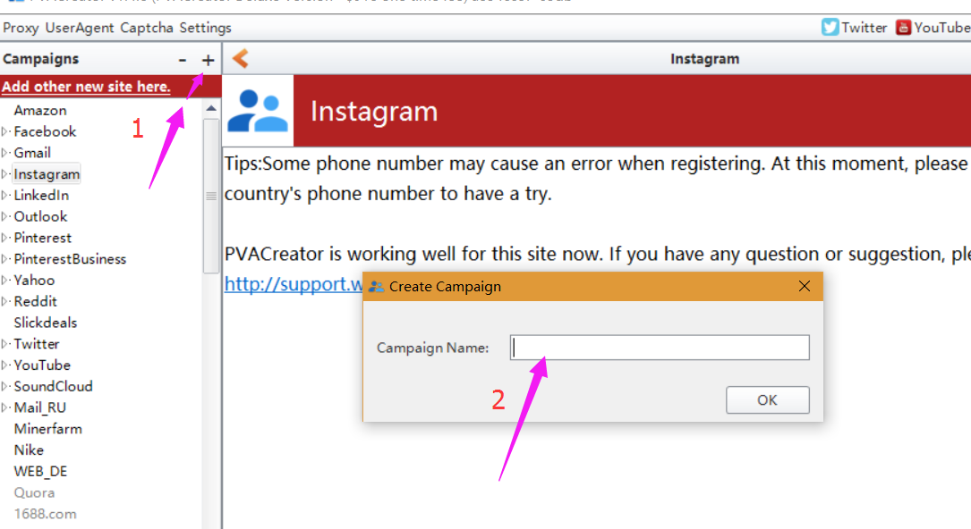

How to enter value for these options?
1. manually input value for them one by one.
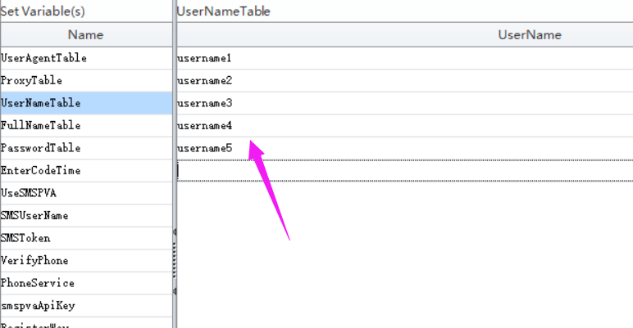
- click “BindData” to choose “Import from file” option to upload multiple data at a time.
Note: please check this column (the checked column color will be yellow) first which you need to multiple upload data.
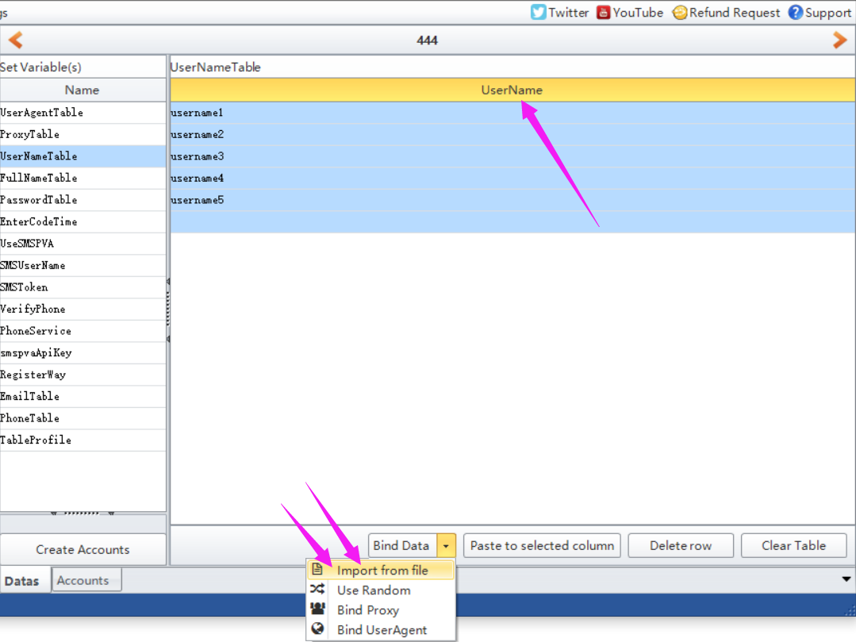
- click “BindData” to choose “Use Random” option to auto generate some data based on the condition you preset.
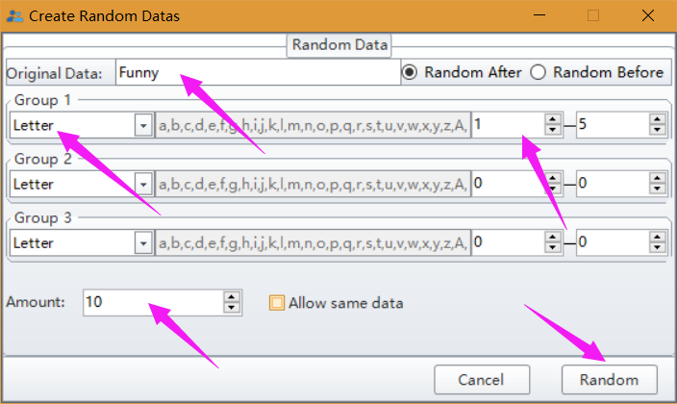
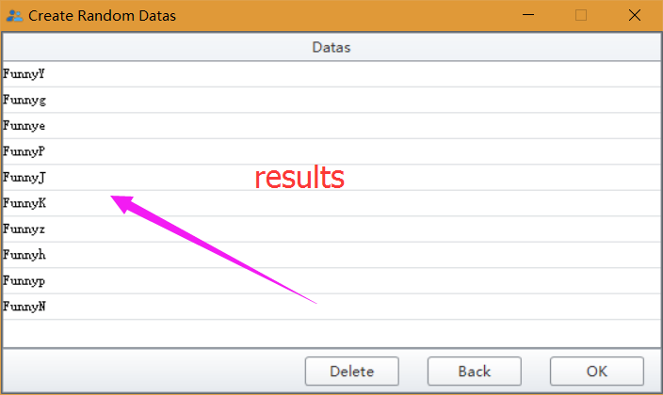

Note: please do not forget to click “Create Account” button to save the data you entered/modified.
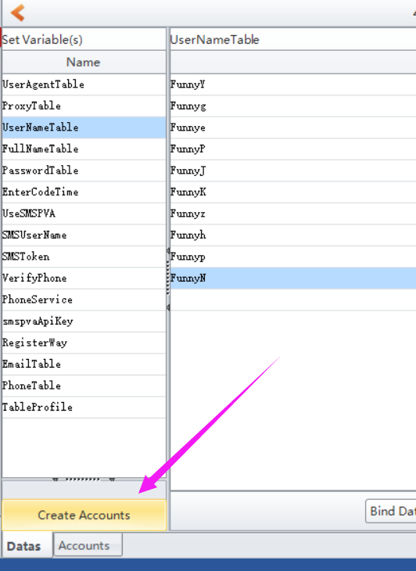

Where to find the data i entered?
Click Accounts button, then you can find all data you entered in this form:
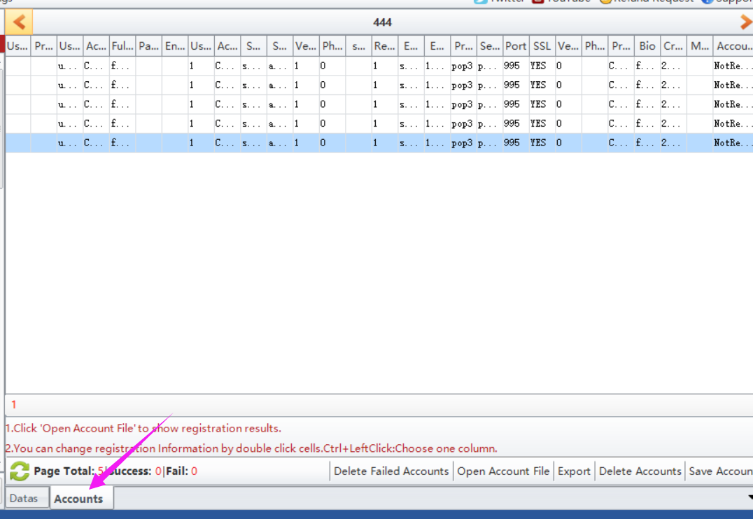

Where to start to run the task?
Click Start button to run.
