How to Register Facebook Account

1. Create a Task name
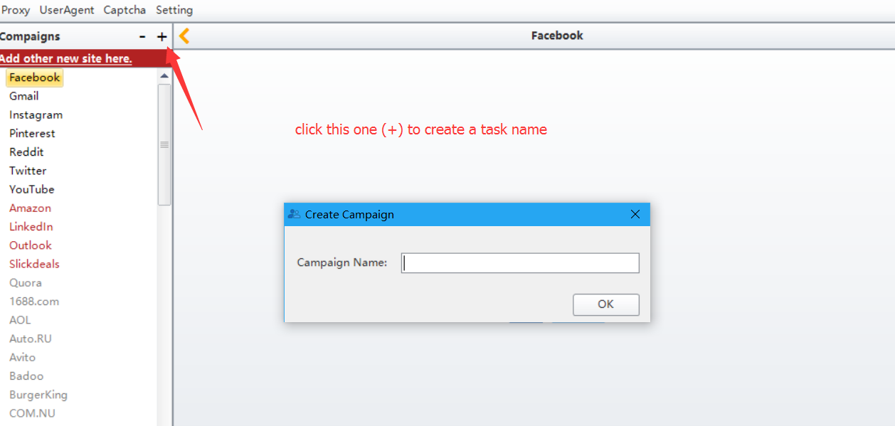

- Fill in the email address to register.
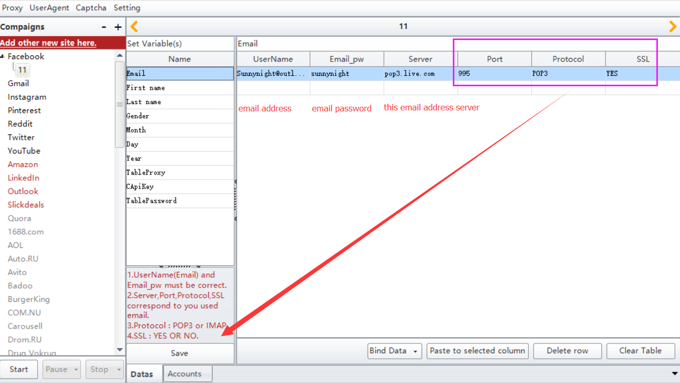

3. Fill in the First name. Do the same operation for Last name.
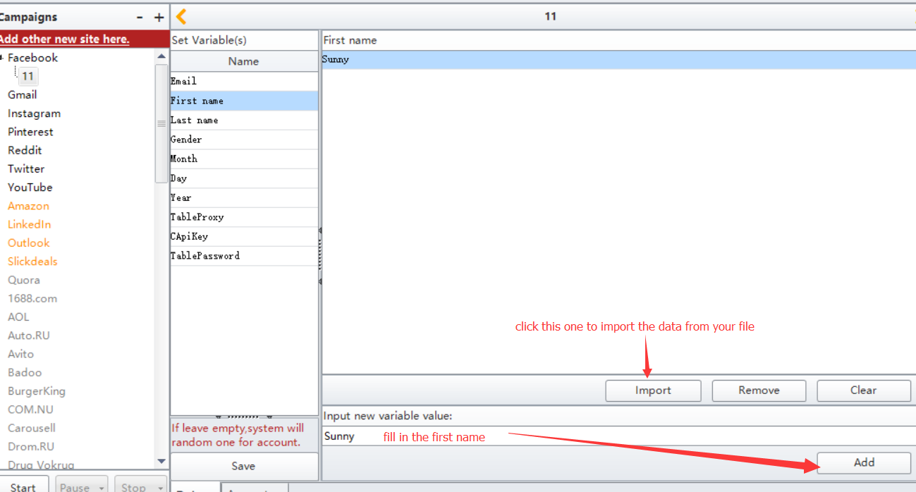

4. Fill in 0, 1, 2 represents Sex
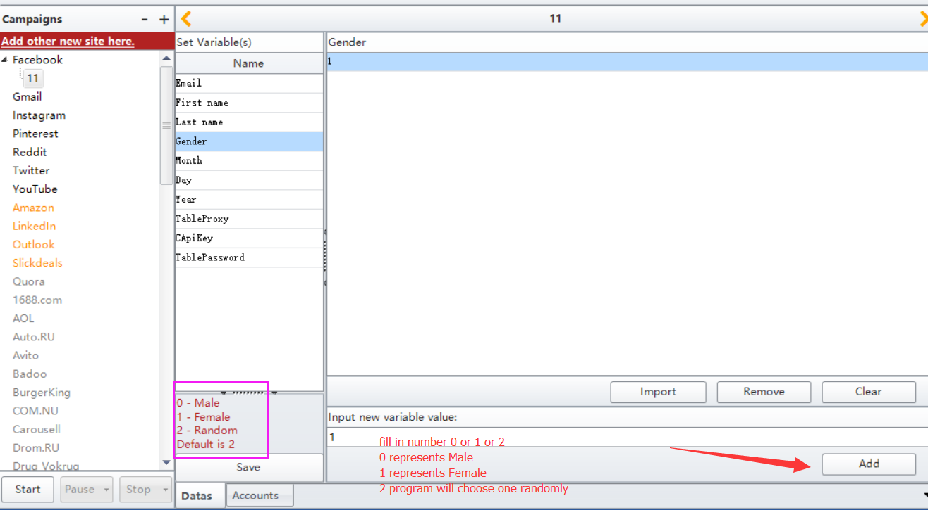

5. Fill in number 1-12 represents Month. Fill in number 1-31 represents Day. Fill in 1905-currently year represents Year
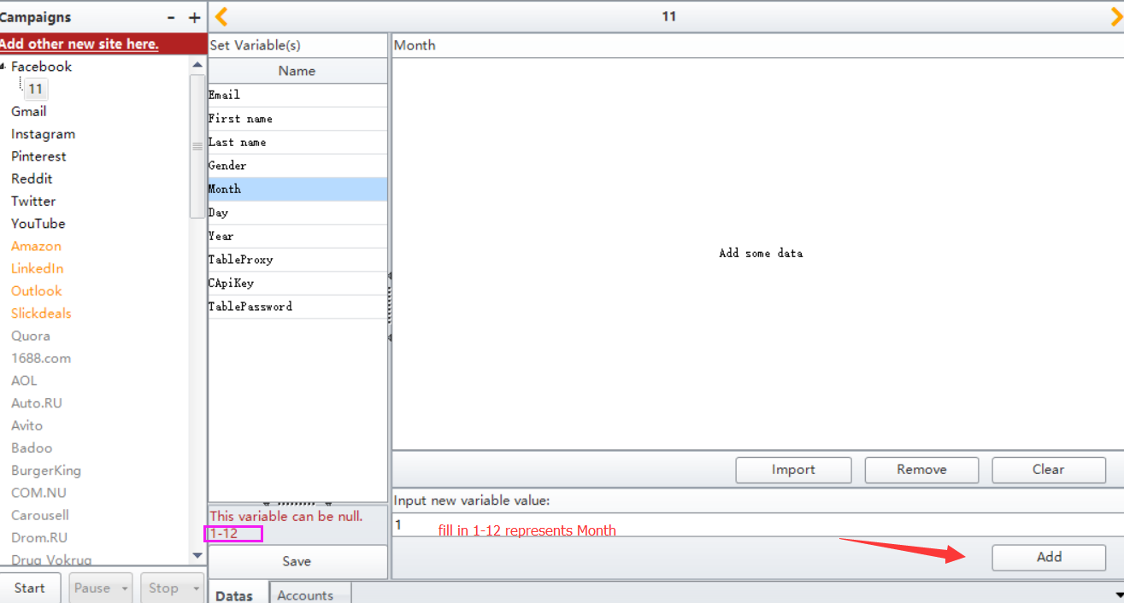

6. Fill in the proxy
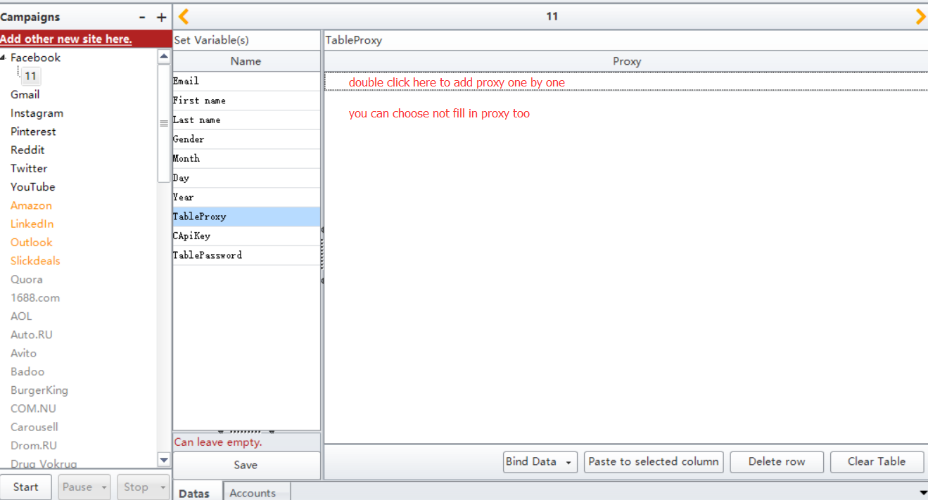

7. Fill in your 2captcha account api, so program can use the 2captcha service to auto verify the captcha
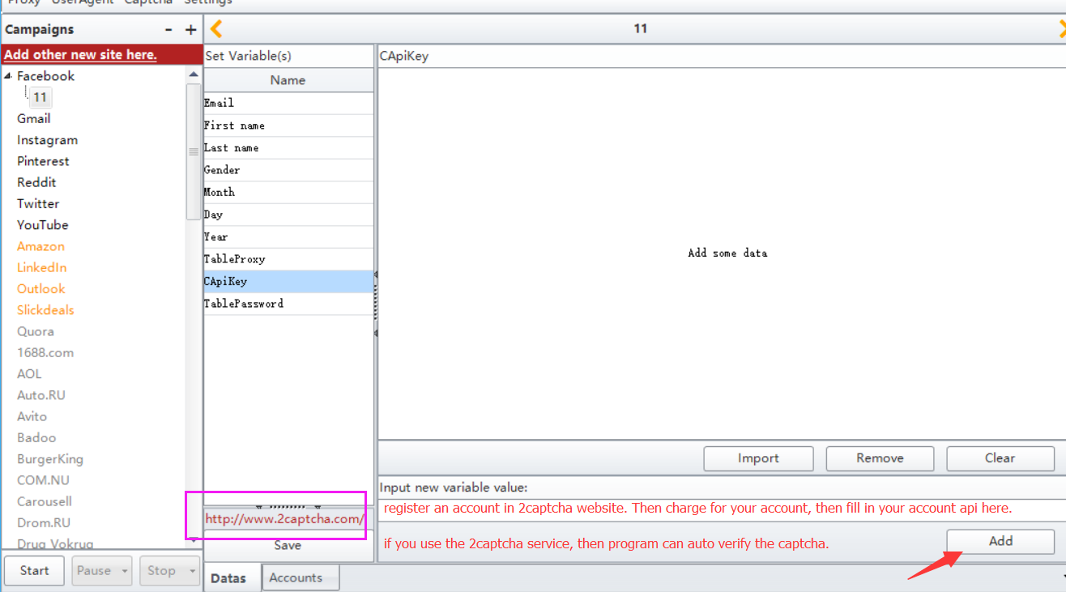

8. Fill in a password to create account or let the program generate one randomly
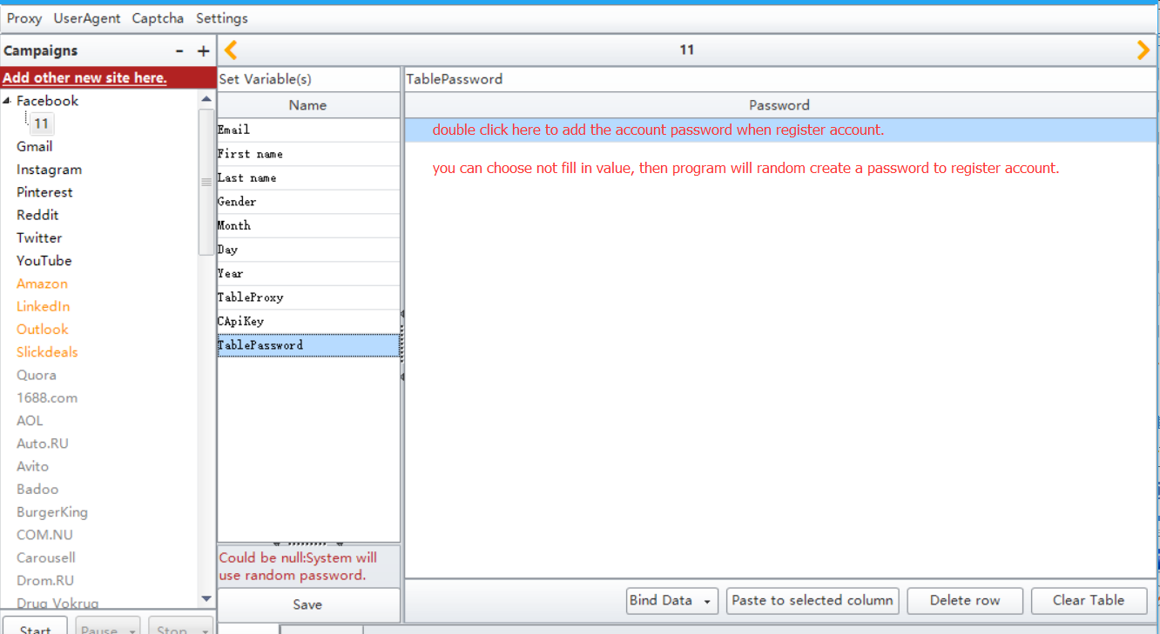

9. Click the Save button to save the data you write
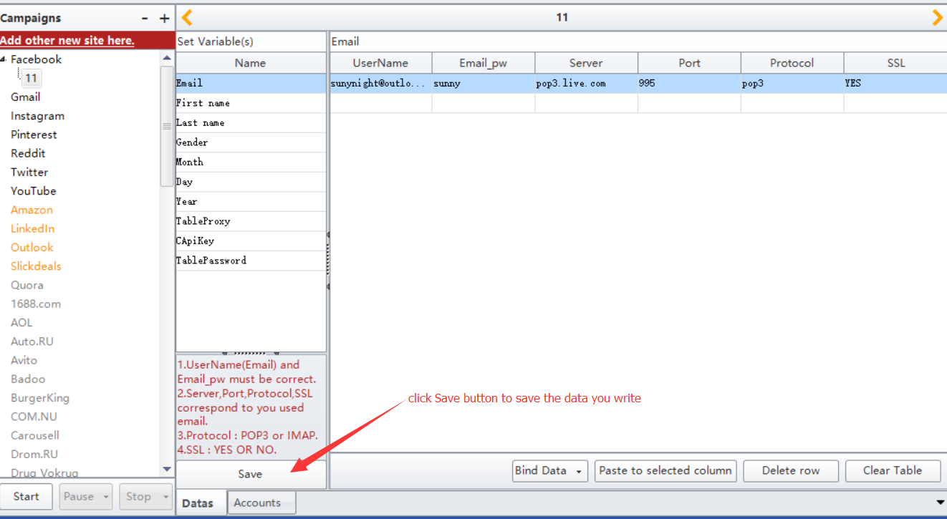

10. Select Accounts, then in this form, you can see all data you just write
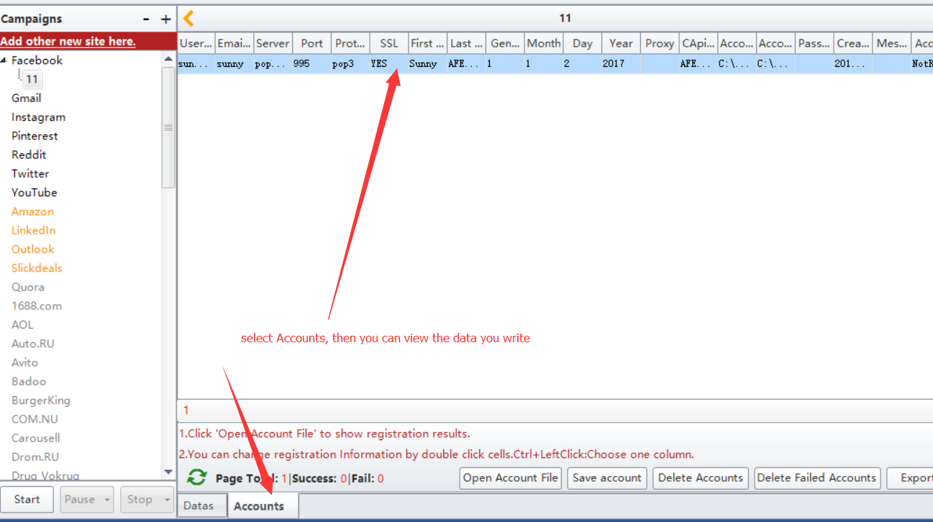

11. Click Start button to start to register accounts
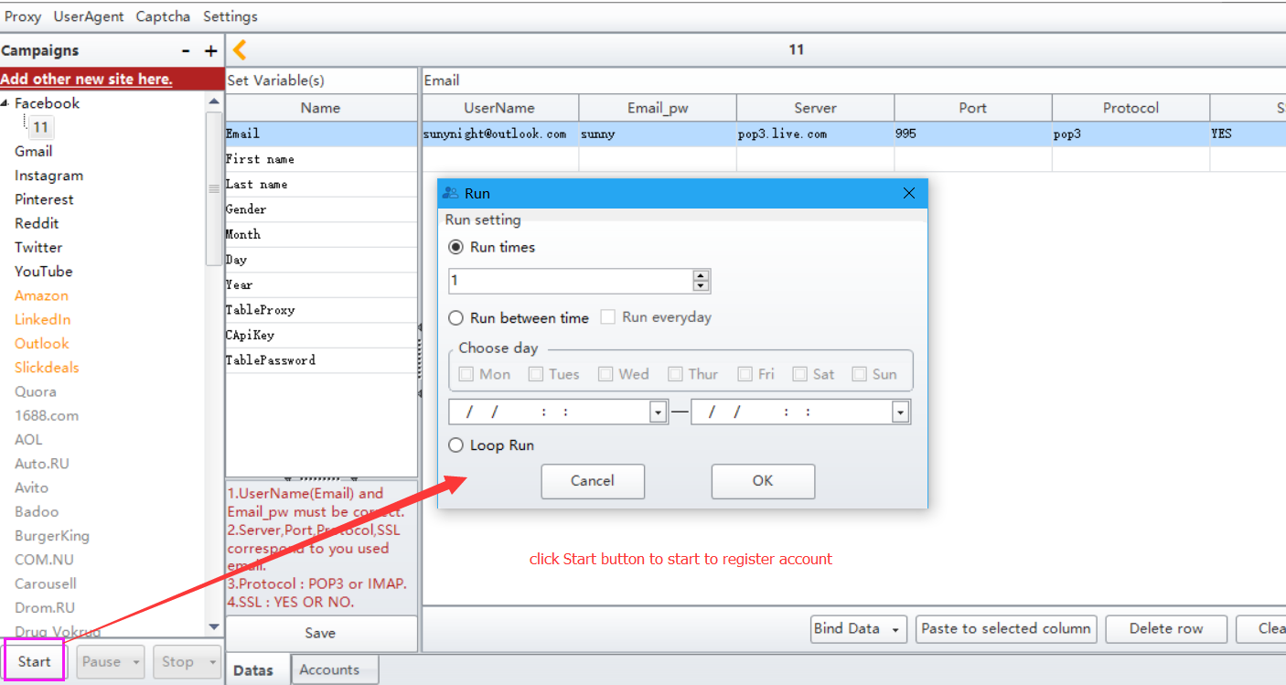

12. If this data has been created successfully, then the status here will be True. Else it will be false
